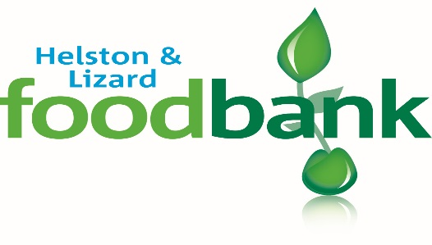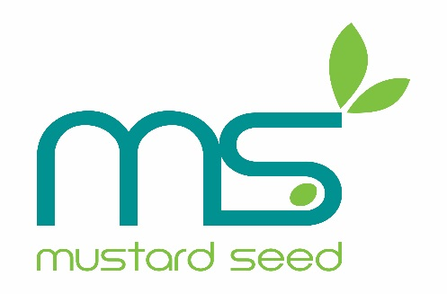

July 2016

Dear Parent/Guardian,

The foodbank is very aware that having your children home for the holidays stretches resources to the limit. Children eat so much more when they are running and playing, using more energy! We would like to offer you the opportunity to receive food to help you through this period. To this end you will find enclosed a compliment slip. If you would like to bring this to the foodbank at the Open Door Café, Mustard Seed in Wendron Street, Helston (opposite the cinema).
This compliment slip will entitle you to three separate food boxes for you to collect at your convenience during the summer holidays.

We at Mustard Seed appreciate how difficult feeding your family can be and always use discretion and confidentiality. Come and see us, we are a friendly bunch, honestly!

Opening hours to redeem vouchers are 10am to 2pm on Mondays, Wednesdays and Fridays, except Bank Holiday Monday 29th August.

Ruth McGurk
Co-ordinator Helston & Lizard foodbank

