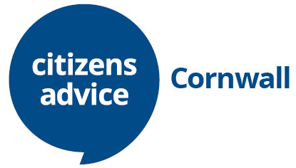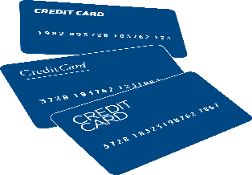

Taking Control of Your Money
How you can improve your budgeting and reduce family spending

BUDGETING
You can use online budgeting tools, planners and guides, including calculators, that help you plan for life changes, such as having a baby, getting married or just planning for Christmas.
www.citizensadvice.org.uk/debt-and-money/budgeting/budgeting/work-out-your-budget

MORTGAGES

Reducing Your Mortgage Costs: If you're struggling to pay your mortgage, you must take action quickly to stop yourself from falling into debt.
If you get into debt and your lender thinks you’re not dealing with the problem, they will take action through the courts. This could lead to you losing your home.
You could look at switching to a cheaper mortgage or insurance deal, cutting down your monthly payments or changing payments on your endowment policy.
Find out how on our website https://www.citizensadvice.org.uk/debt-and-money/mortgage-problems/how-to-sort-out-your-mortgage-problems/cutting-down-your-mortgage-costs/

If you’re having serious difficulties paying your mortgage, for example, if you’ve started getting letters from your lender threatening court action, you should get help from an experienced debt adviser, such as the Citizens Advice Cornwall Debt Team – Text ADVICE DEBT to 78866.

COUNCIL TAX BILLS:
If you're on a low income, you may be entitled to help from your council towards paying your council tax. In some cases you may be entitled to money off your council tax bill, or you may not have to pay council tax at all (called an exemption).
See cornwall.gov.uk/council-tax/get-money-off-your-council-tax/ for details. You can also ask your local authority to spread the cost of your council tax over 12 months instead of 10 cornwall.gov.uk/council-and-democracy/council-tax

SAVE ON INSURANCE
Shop around for the best insurance deals for all of your insurance; including your house (building and contents), life, car, travel and health (check out www.moneysavingexpert.com/insurance for ideas). Review your policies to see if you still need them or check whether they provide more cover than you need.

If you’re worried about your debts, seek help from our specialist debt team as soon as you can for free, independent and confidential advice and support. Just text ADVICE DEBT to 78866.

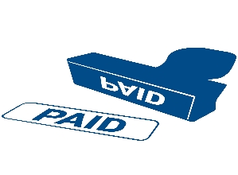
PUBLISHED BY CITIZENS ADVICE CORNWALL. CHARITY REGISTRATION NUMBER 1096193. REGISTERED OFFICE: 21 DEAN ST, LISKEARD PL14 4AB

