Landewednack School & Little Lizards
OPEN AFTERNOON
On Monday 7th November 2016
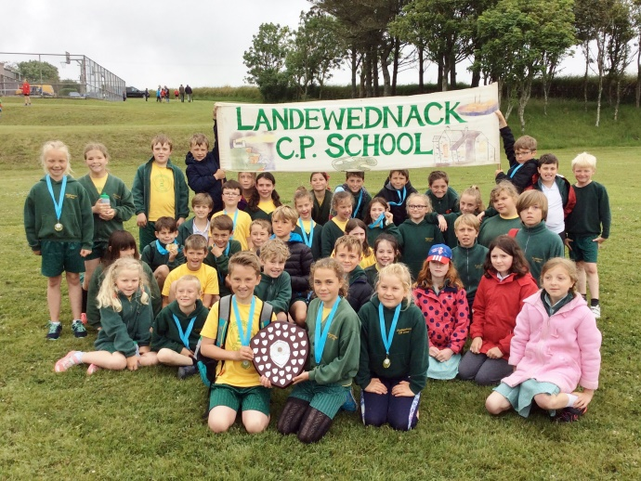
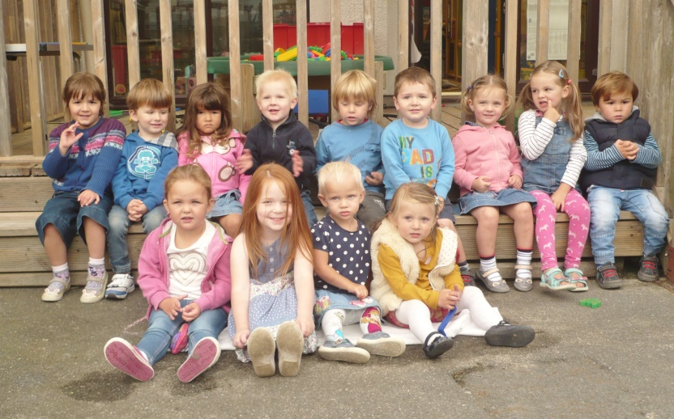
From 1.30pm – 2.30pm

Is your child due to start school in September 2017?
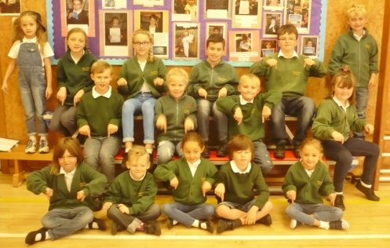
If so let us invite you to browse around our class rooms, nursery and play areas. Just call in!
For more information please call
Landewednack School - 01326 290337
Little Lizards – 01326 290066
