Landewednack Community Primary School
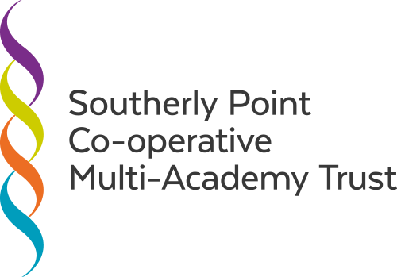
Beacon Terrace
The Lizard
HELSTON
Cornwall
TR12 7PB
Tel: 01326 290337
www.landewednack.cornwall.sch.uk

Headteacher: Mrs L. Jones - head@landewednack.cornwall.sch.uk

Dear Parents,
We have all been living in very strange times and as such I wondered how you have all been getting on and how your children are coping. I know you have been in regular contact with your child’s teacher and the communications between you all have been amazing!
With this week denoting the start of a phased return to school for some of our children, I felt it appropriate to say that I am still working part-time in my SENCo role, and I would like to help wherever needed with the well-being of our children and families.
I have been doing some online courses on subjects relating to the pandemic, such as coping with bereavement, mindfulness and building relationships after Covid.
If you feel that your child is anxious or worried about something or just the situation as a whole and would benefit from time to talk then please contact me by any of the means below and I will get back to you asap. Regardless of whether your child is currently about to attend school or is not coming, I am sure that I will be able to arrange a face to face Thrive time session which will be socially distanced and mindful of all the government guidelines. Similarly if I can offer a listening ear to yourselves as parents and home tutors, please let me know.
There is a classroom at school which I am able to use solely for this purpose, which has its’ own entrance so I will be adhering to all the rules.
I hope you are all safe and well and remain so in these uncertain times and I look forward to seeing you all again in the near future.
Kind regards, Judith Green

judith@landewednack.cornwall.sch.uk
Or telephone 290337 and leave a message with Lyndsay.

