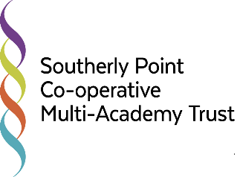
Southerly Point Co-operative Multi-Academy Trust
DATA PROTECTION AND
FREEDOM OF INFORMATION POLICY

Equality Impact Assessment
The EIA has not identified any potential for discrimination or adverse impact and all opportunities to promote equality have been taken.*
The EIA has not identified any conflict with the Trust’s co-operative values and the Church Schools’ values.
Adjust the policy to remove barriers identified by the EIA or better promote equality.
*Inclusive of protected characteristics
Provenance | Date
Working Party | Oct 2017
HR checks | N/A
Union Consultation | Oct 2017
Trustees | Dec 2017
Implementation | Feb 2018
Review Date
Review by April 2018 in light of GDPR
Review April 2020

To be read in conjunction with: | Online Safety and Data Security Policy  Safeguarding

School
Data Controller | CEO Donna Bryant  MAT Office, Helston Community School South Site, Church Hill, Helston. TR13 8NR  Email: dbryant@southerlypoint.co
Data Manager
Southerly Point Co-operative Multi-Academy Trust
DATA PROTECTION AND FREEDOM OF INFORMATION POLICY
- Aims & Objectives:

1.1 The aim of this policy is to provide a set of guidelines to enable staff, parents and students to understand:
- The law regarding personal data
- How personal data should be processed, stored, archived and deleted/destroyed
- How staff, parents and students can access personal data
1.2 In addition, there is brief guidance at the end of the policy on Freedom of Information which covers other information held by schools.
1.3 The objective of the policy is to ensure that the Trust and its schools act within the requirements of the Data Protection Act 1998 when retaining and storing personal data, and when making it available to individuals, and that the process of responding to enquiries for other information is also legal under the Freedom of Information Act 2000 (in force from 1st January 2005).
- What is Personal Information?
Personal information or data is defined as data which relates to a living individual who can be identified from that data, or other information held. It includes any expression of opinion about the individual and any indication of the intentions of the data controller or any other person in respect of the individual.

- Data Protection Principles
The Data Protection Act 1998 establishes eight enforceable principles that must be adhered to at all times:
- Personal data shall be processed fairly and lawfully;
- Personal data shall be obtained only for one or more specified and lawful purposes;
- Personal data shall be adequate, relevant and not excessive;
- Personal data shall be accurate and where necessary, kept up to date;
- Personal data processed for any purpose shall not be kept for longer than is necessary for that purpose or those purposes;
- Personal data shall be processed in accordance with the rights of data subjects under the Data Protection Act 1998;
- Personal data shall be kept secure i.e. protected by an appropriate degree of security;
- Personal data shall not be transferred to a country or territory outside the European Economic Area, unless that country or territory ensures an adequate level of data protection.

- Data Protection – the law:
4.1 Under the Data Protection Act 1998, and other regulating acts, access to their own personal information is a statutory right for students (if they are of an age to understand the information they request) and parents (as defined in the Education Act 1996) may also request access to their child’s personal data.
4.2 Trust staff have a right of access to personal data on themselves.
4.3 Anyone has the right to question and correct inaccurate information, but this must be matters of fact, not opinions.
4.4 Personal data should always be kept securely and protected by passwords if it is electronic, and access to it should only be by those authorised to see it – confidentiality should be respected. The law also provides that personal data should not be kept longer than is required.
4.5 Third party data (information about someone other than the requesting individual) should in general only be provided with their permission.
4.6 The member of staff with overall responsibility for personal data within the Trust is Donna Bryant

Processing, storing, archiving and deleting personal data: guidance

  - Personal data and school records about students are confidential to the child. This information can be shared appropriately within the professional working of the school to enable the school to make the best educational provision for the child. The law permits such information to be shared with other educational establishments when pupils change schools.

  - A retention schedule for School records can be found at Appendix A.

Accessing personal data: guidance

  - A child can request access to his/her own data. The request is not charged and does not have to be in writing. Senior staff will judge whether the request is in the child’s best interests, and that the child will understand the information provided. They may also wish to consider whether the request has been made under coercion.

  - A parent can request access to or a copy of their child’s Trust records and other information held about their child. The request must be made in writing. There is no charge for such requests on behalf of the child, but there may be a charge for photocopying records – this is detailed in guidance available from the Information Commissioner. Staff should check, if a request for information is made by a parent, that no other legal obstruction (for example, a court order limiting an individual's exercise of parental responsibility) is in force.

  - Parents should note that all rights under the Data Protection Act to do with information about their child rest with the child as soon as they are old enough to understand these rights. This will vary from one child to another, but, as a broad guide, it is reckoned that most children will have a sufficient understanding by the age of 12. Parents are encouraged to discuss and explain any request for information with their child if they are aged 12 or over.

  - Separately from the Data Protection Act, The Education (Pupil Information)(England) Regulations 2005 provide a student’s parent (regardless of the age of the student) with the right to view, or to have a copy of, their child’s educational record at the Trust. Parents who wish to exercise this right must apply to the Trust in writing.

  - For educational records (unlike other personal data; see below) access must be provided within 15 Trust days, and if copies are requested, these must be supplied within 15 Trust days of payment

  - A member of staff can request access to their own records at no charge, but the request must be made in writing. The member of staff has the right to see their own records, and to ask for copies of the records. There is a maximum charge of £10 for copies of records.

  - The law requires that all requests for personal information are dealt with within 40 days of receipt except requests for educational records (see above). All requests will be acknowledged in writing on receipt, and access to records will be arranged as soon as possible. If awaiting third party consents, the Trust will arrange access to those documents already available, and notify the individual that other documents may be made available later.

  - In all cases, should third party information (information about another individual) be included in the information the staff will try to obtain permission to show this information to the applicant, with the exception of information provided by another member of Trust staff (or local authority staff) which is exempt from a requirement for third party consents. If third party permission is not obtained the person with overall responsibility should consider whether the information can still be released.

  - Personal data should always be of direct relevance to the person requesting the information. A document discussing more general concerns may not be defined as personal data.

  - From 1st January 2005, when the Freedom of Information Act came fully into force, a request for personal information can include unstructured as well as structured records – for example, letters, emails etc. not kept within an individual’s personal files, or filed by their name, but still directly relevant to them. If these would form part of a wider record it is advisable to file these within structured records as a matter of course and to avoid excessive administrative work. These can be requested if sufficient information is provided to identify them.

  - Anyone who requests to see their personal data has the right to question the accuracy of matters of fact within the data, and to ask to have inaccurate information deleted or changed. They may also question opinions, and their comments will be recorded, but opinions do not need to be deleted or changed as a part of this process.

  - The Trust will document all requests for personal information with details of who dealt with the request, what information was provided and when, and any outcomes (letter requesting changes etc.) This will enable staff to deal with a complaint if one is made in relation to the request.

Fair processing of personal data: data which may be shared

  - Schools, local education authorities and the Department for Education (DfE) all hold information on students in order to run the education system, and in doing so have to follow the Data Protection Act 1998. This means, among other things,that the data held about students must only be used for specific purposes allowed by law. The Trust has a Privacy Notice which explains how personal data is used and with whom it will be shared. This Notice is contained in Appendix 2 and is also published on school websites (policies) and on www.southerlypoint.co

  - The Local Authority uses information about students to carry out specific functions for which it is responsible, such as the assessment of any special educational needs the student may have. It also uses the information to derive statistics to inform decisions on (for example) the funding of schools, and to assess the performance of schools and set targets for them. The statistics are used in such a way that individual students cannot be identified from them.

  - Information on how to access personal data held by other organisations is given below.

  - Students, as data subjects, have certain rights under the Data Protection Act, including a general right of access to personal data held on them, with parents exercising this right on their behalf if they are too young to do so themselves. If your child wishes to access their personal data, or you wish to do so on their behalf, then please contact the relevant organisation in writing:
- the Trust as above;
- the LA’s Policy Officer (Information) at County Hall.

- Access to other Trust information – Freedom of Information Act and Environmental Information Regulations

  - Under the Freedom of Information Act 2000, all schools (primary, secondary and nursery) should have a ‘publication scheme’ – essentially a formal list of the types of non-personal information which the Trust produces or holds, and which is readily accessible to staff, students and parents or other enquirers. See Appendix 3

  - The publication scheme is posted on both the school and Trust website and can be made available as a hard copy if requested.

  - Information which is not covered by the publication scheme can be requested by individuals within or outside the Trust under the Freedom of Information Act and Environmental Regulations Act.

Requests for information

  - The access provisions for the Freedom of Information Act came fully into force on 1st January 2005. Under this Act, all schools which receive a written or emailed request for information which they hold or publish are required to respond within 20 school days (or 60 working days, whichever is shorter).

  - When handling a request for information the school’s data manager will ask themselves a series of questions. These are set out in Appendix 4 as process maps.

  - A request for information may be covered by one, or all, of three information rights:

- Data Protection enquiries (or subject access requests) are ones where the enquirer asks to see what personal information the Trust holds about the enquirer. If the enquiry is a Data Protection request, we will follow our existing DPA guidance.

- Environmental Information Regulations enquiries are ones which relate to air, water, land, natural sites, built environment, flora and fauna, and health, and any decisions and activities affecting any of these. These could therefore include enquiries about recycling, phone masts, school playing fields, car parking etc. If the enquiry is about environmental information, we will follow the guidance on the ICO’s website or the DEFRA website.

- FOI enquiries are concerned with all other information and the reasoning behind decisions and policies. The request does not have to mention the FOI Act. All requests for information that are not data protection or environmental information requests are covered by the FOI Act.

  - If it is a valid FOI request the Trust will provide guidance on where to access the information required eg. the website link, or details of a charge if the publication/ information is charged, or send any free information. If the item is charged the Trust does not need to provide it until the payment is received. In these cases the Trust must give the person requesting the information notice in writing (the “fees notice” Appendix 5) stating that a fee of the amount specified in the notice is to be charged for complying. We reserve the right to refuse to supply information where the cost of doing so exceeds the statutory maximum, currently £450

  - A refusal of any information requested must state the relevant exemption which has been applied or that the Trust does not hold the information, and must explain what public interest test has made if this applies.

  - If the information is published by another organisation (for example, Ofsted reports, DfE leaflets) the Trust can direct the enquirer to the organisation which supplied the information or publication unless it is legal and possible to provide the information direct (for example, a copy of the summary of an Ofsted report, spare copies of a DfE leaflet ).

  - It will not be legal to photocopy a publication in its entirety and supply this to an enquirer unless the Trust owns the copyright – this is particularly important where the original publication was a charged item.

  - The Trust will keep the original request and note against this who dealt with the request and when the information was provided.

  - Any complaint about the provision of information will be dealt with under the complaints procedure. All complaints should be in writing and documented. The Publication Scheme will include information on who to contact for both enquiries and complaints.
All enquirers should be advised that they may complain to the Information Commissioner if they are unhappy with the way their request has been handled.
Appendices
Referenced in the Policy
Appendix 1 – Retention schedule
Appendix 2 - Privacy Notice for Students
Appendix 3 – Freedom of Information Publication Scheme
Appendix 4 – Freedom of Information Process Map
Appendix 5 – Freedom of Information Fees Notice
Other relevant Documents
Appendix 6 – Privacy Notice for Trust Workforce
Appendix 7 – Use of CCTV

Appendix 1
Retention Schedule
Please refer to the retention schedules from the IRMS Information Management Toolkit for schools. This can be accessed via the following link:

Appendix 2

PRIVACY NOTICE

Pupils in Schools, Alternative Provision and Pupil Referral Units

Privacy Notice for Pupils - Data Protection Act 1998

Your school, __________________ is part of the Southerly Point Co-operative Multi-Academy Trust, who is a data controller for the purposes of the Data Protection Act. Your school collects personal information from you and may receive information about you from your previous school and the Learning Records Service. This personal data is held to:

- Support your learning;

- Monitor and report on your progress;

- Provide appropriate pastoral care, and

- Assess how well we are doing.

Information about you that is held includes your contact details, national curriculum assessment results, attendance information and personal characteristics such as your ethnic group, any special educational needs you may have and relevant medical information. If you are enrolling for post 14 qualifications the Learning Records Service will give us your unique learner number (ULN) and may also give us details about your learning or qualifications.

Once you are aged 13 or over, the school is required by law to pass on certain information to providers of youth support services in your area. This is the local authority support service for young people aged 13 to 19 in England. The school must provide the names and addresses of you and your parent(s), and any further information relevant to the support services’ role.

However, if you are over 16, you (or your parent(s)) can ask that no information beyond names, addresses and your date of birth be passed to the support service. This right transfers to you on your 16th birthday. Please tell the school Registrar, __________, if you wish to opt out of this arrangement. For more information about young people’s services, please go to the National Careers Service page at https://nationalcareersservice.direct.gov.uk/aboutus/Pages/default.aspx

We will not give information about you to anyone without your consent unless the law and our policies allow us to.

We are required by law to pass some information about you to our Local Authority (LA) and the Department for Education.

If you want to receive a copy of the information about you that we hold or share, please contact the school’s Registrar,_______________.

If you need more information about how the LA and DfE store and use your information, then please go to the following websites:

http://www.cornwall.gov.uk/default.aspx?page=20730 or
http://www.education.gov.uk/researchandstatistics/datatdatam/b00212337/datause

If you cannot access these websites, please contact the LA or DfE as follows:

- The Local Authority’s Data Protection Officer can be contacted at Cornwall Council, County Hall, Truro, Cornwall, TR1 3AY
Website: www.cornwall.gov.uk
Telephone: 0300 1234 101

- Public Communications Unit
Department for Education
Sanctuary Buildings
Great Smith Street
London
SW1P 3BT
Website: www.education.gov.uk
Email: http://www.education.gov.uk/help/contactus
Telephone: 0370 000 2288

CCTV system (include if the school has CCTV)

The school operates a CCTV system and the images produced by it are controlled by the school in line with the Data Protection Act 1998.

CCTV equipment is used to provide a safer, more secure environment for students and staff and to help prevent bullying, vandalism and theft. Essentially it is used for:
- The prevention, investigation and detection of crime.
- The apprehension and prosecution of offenders (including use of images as evidence in criminal proceedings).
- Safeguarding public, student and staff safety.
- Monitoring the security of the site.
- The School does not use the CCTV system for covert monitoring.

Images from this CCTV system are securely stored, where only a limited number of authorised persons may have access to them.

The recorded images will only be retained long enough for any incident to come to light (eg for a theft to be noticed) and the incident to be investigated.

Except for law enforcement bodies, images will not be provided to third parties.

The potential impact on individuals’ privacy has been identified and taken into account in the use of the system.

Appendix 3

Freedom of Information Publication Scheme

- Introduction: what a publication scheme is and why it has been developed
This publication scheme commits Southerly Point Co-operative Multi-Academy Trust to make information available to the public as part of its normal business activities. The information covered is included in the classes of information mentioned below where this information is held by the Trust.
The scheme commits the Trust and its schools:
- To proactively publish or otherwise make available as a matter of routine, information, including environmental information, which is held by the Trust and its schools and falls within the classifications below.
- To specify the information which is held by Helston Community School and falls within the classifications below.
- To proactively publish or otherwise make available as a matter of routine, information in line with the statements contained within this scheme.
- To produce and publish the methods by which the specific information is made routinely available so that it can be easily identified and accessed by members of the public.
- To review and update on a regular basis the information the Trust and its schools makes available under this scheme.
- To produce a schedule of any fees charged for access to information which is made proactively available.
- To make this publication scheme available to the public.

2. Classes of information
2.1 Who we are and what we do.
Organisational information, locations and contacts, constitutional and legal governance.
2.2 What we spend and how we spend it.
Financial information relating to projected and actual income and expenditure, tendering, procurement and contracts.
2.3 What our priorities are and how we are doing.
Strategy and performance information, plans, assessments, inspections and reviews.
2.4 Our policies and procedures.
Current written protocols for delivering our functions and responsibilities.
2.5 The services we offer.
Information about the services the Trust and its schools provide including leaflets, guidance and newsletters.
Further details are given in the ICO publication - Definition document for the governing bodies of maintained and other state-funded schools in England
https://ico.org.uk/media/for-organisations/documents/1235/definition-document-schools-in-england.pdf
The classes of information will not generally include:
- Information the disclosure of which is prevented by law, or exempt under the Freedom of Information Act, or is otherwise properly considered to be protected from disclosure.
- Information in draft form.
- Information that is no longer readily available as it is contained in files that have been placed in archive storage, or is difficult to access for similar reasons.

3. The method by which information published under this scheme will be made available
Where it is within the capability of the Trust and its schools, information will be provided on our website. Where it is impracticable to make information available on a website or when an individual does not wish to access the information by the website, we will indicate how information can be obtained by other means and provide it by those means.
In exceptional circumstances some information may be available only by viewing in person. Where this manner is specified, contact details will be provided. An appointment to view the information will be arranged within a reasonable timescale.
Information will be provided in the language in which it is held or in such other language that is legally required. Where an authority is legally required to translate any information, it will do so.
Obligations under disability and discrimination legislation and any other legislation to provide information in other forms and formats will be adhered to when providing information in accordance with this scheme.

4. Charges which may be made for information published under this scheme
The purpose of this scheme is to make the maximum amount of information readily available at minimum inconvenience and cost to the public. Charges made by the Trust and its schools for routinely published material will be justified and transparent and kept to a minimum.
Material which is published and accessed on a website will be provided free of charge.
Charges may be made for information subject to a charging regime specified by Parliament.
Charges may be made for actual disbursements incurred such as:
- photocopying
- postage and packaging
- the costs directly incurred as a result of viewing information

Charges may also be made for information provided under this scheme where they are legally authorised, they are in all the circumstances, including the general principles of the right of access to information held by public authorities, justified and are in accordance with a published schedule or schedules of fees which is readily available to the public.
If a charge is to be made, confirmation of the payment due will be given before the information is provided. Payment is required prior to provision of the information.

5. Written requests
Information held by the Trust and its schools that is not published under this scheme can be requested in writing, when its provision will be considered in accordance with the provisions of the Freedom of Information Act.
6. Contact details
If you require a paper version of any information, or want to ask whether information is available please contact the school by telephone, email or letter. Contact details are set out on the cover page of this policy or you can visit the Trust website www.southerlypoint.co
To help us process your request quickly, please clearly mark any correspondence “PUBLICATION SCHEME REQUEST” (in CAPITALS please)
If the information you’re looking for isn’t available via the scheme and isn’t on our website, you can still contact the Trust or individual school to ask if we have it.
Appendix 4
Freedom of Information Process Map
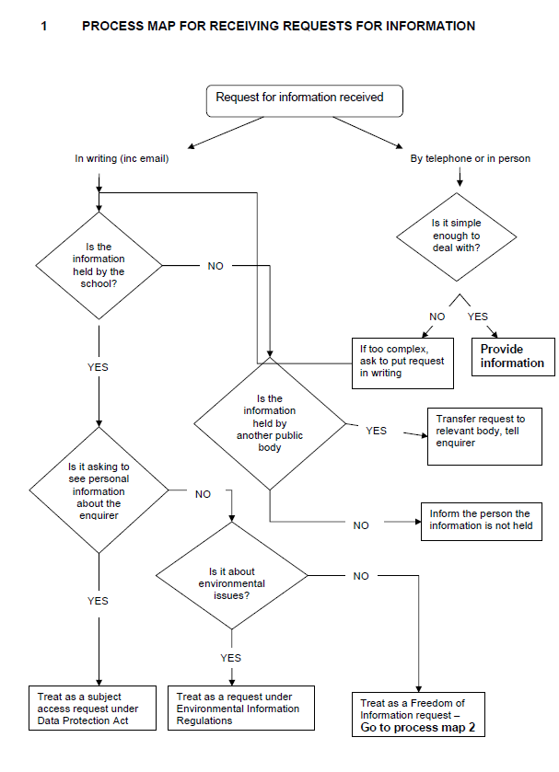

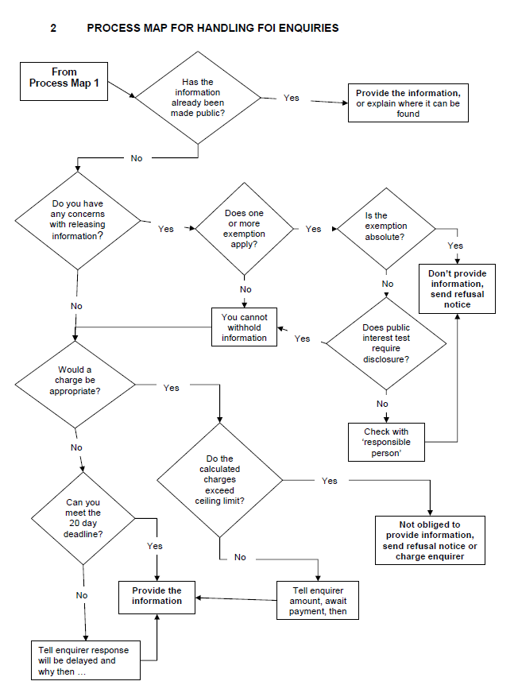

Appendix 5

Freedom of Information Fees Notice

STATEMENT
This Fees Notice is submitted by Southerly Point Co-operative Multi-Academy Trust in accordance with Section 9 of the Freedom of Information Act 2000 (the FOI Act) and requires the payment of the fee(s) within a period of three months, beginning with the day this Fees Notice is received by the Applicant. Failure to pay the fee(s) within the prescribed period will result in the discharge of Southerly Point Co-operative Multi-Academy Trust’s obligations under the FOI Act.

Please read the Note accompanying this Fees Notice
1. Applicant’s Details
NAME:
ADDRESS:
TEL:
FAX:
EMAIL:
2. Information Requested

3. Applicant’s request applies to documents from to

4. Fees Due £
1. search, retrieval and collation
2. photocopying
3. printing
4. postage
5. priced publication
6. any other disbursements

Total Due £
Date:

Please make your payment by cheque, payable to Southerly Point Co-operative Multi-Academy Trust, and forward your cheque to:
The Business Manager, MAT Office, Helston Community College, Church Hill, Helston, Cornwall, TR13 8NR

Whilst Southerly Point Co-operative Multi-Academy Trust must respond to your request for information within 20 working days of the date of receipt of your application, please note that this time period does not begin to run until you have paid the fee(s).

If you pay the fee(s) within a period of three months, Southerly Point Co-operative Multi-Academy Trust must, subject to the consideration of exemptions, comply with your request for the information detailed in your application and this Fees Notice.

NOTE

Fees are regulated by Fees Regulations and the ‘appropriate fee’ for Southerly Point Co-operative Multi-Academy Trust as a public authority is £450.00 (referred to in this Note as the ‘Threshold’). Where charges apply, a Fees Notice will be sent to you within 20 working days’ of receipt of your written application. You must pay the specified fee within 3 months of receiving the Fees Notice. If payment is not made within this period, Southerly Point Co-operative Multi-Academy Trust is not obliged to process your application; in other words the clock stops while Southerly Point Co-operative Multi-Academy Trust is awaiting payment from you.

NB: The period beginning with the giving of the Fees Notice and ending with receipt of the fee by Southerly Point Co-operative Multi-Academy Trust is disregarded in calculating the period required for Southerly Point Co-operative Multi-Academy Trust to comply with the request for information.

Search, retrieval and collation

Where the information you are seeking is already available in a priced publication, Southerly Point Co-operative Multi-Academy Trust will provide you with details of the publication and where to obtain it.

Southerly Point Co-operative Multi-Academy Trust is not obliged to comply with your request for information if Southerly Point Co-operative Multi-Academy Trust estimates that the search, retrieval and collation costs of complying with the request would exceed the Threshold. The Trust will however give an indication of the information which could be provided within/below the Threshold.

Estimated costs below the Threshold:
There will be no charge for the search, retrieval and collation etc of information where the costs are estimated to be less than the Threshold. Southerly Point Co-operative Multi-Academy Trust may, however, charge the full costs of disbursements e.g. photocopying, postage, video, tape, disk, computer runs etc.

Estimated costs above the Threshold:
Should the time for complying with your request be estimated to exceed 18 hours, there will be a charge of £450 based on £25 per hour per person. In addition to the hourly rate, the School may charge the full costs of disbursements e.g. photocopying, postage, video, tape, disk, computer runs etc. Please note that Southerly Point Co-operative Multi-Academy Trust is not required to comply with the request should it exceed the Threshold.

Multiple requests:
Where two or more requests are made by the same person, or by different persons who appear to be acting in concert, or in pursuance of a campaign, Southerly Point Co-operative Multi-Academy Trust will regard these as one request and estimated costs will be calculated accordingly. This will apply for a period of sixty consecutive working days from the first request.

If your request falls within this category, you will be provided with an estimate of the cost of providing the information before the Southerly Point Co-operative Multi-Academy Trust starts any work on your behalf.

Appendix 6

PRIVACY NOTICE

School Workforce: those employed or otherwise engaged to work at a school or the Local Authority

Privacy Notice - Data Protection Act 1998

__________________ is part of the Southerly Point Co-operative Multi-Academy Trust, who is a data controller for the purposes of the Data Protection Act.

Personal data is held by the Trust and Local Authority about those employed or otherwise engaged to work at the Trust and its schools. This is to assist in the smooth running of the Trust and/or enable individuals to be paid. The collection of this information will benefit both national and local users by:

- Improving the management of school workforce data across the sector;
- Enabling a comprehensive picture of the workforce and how it is deployed to be built up;
- Informing the development of recruitment and retention policies;
- Allowing better financial modeling and planning;
- Enabling ethnicity and disability monitoring; and
- Supporting the work of the School Teacher Review Body and the School Support Staff Negotiating Body.

This personal data includes some or all of the following - identifiers such as name and National Insurance Number and characteristics such as ethnic group; employment contract and remuneration details, qualifications and absence information.
We will not give information about you to anyone outside the Trust or Local Authority (LA) without your consent unless the law and our rules allow us to.
We are required by law to pass on some of this data to:
- the LA
- the Department for Education (DfE)

If you require more information about how the LA and/or DfE store and use this data please go to the following websites:
- http://www.cornwall.gov.uk/default.aspx?page=20730 and
- http://www.education.gov.uk/schools/adminandfinance/schooladmin/a0077963/what-the-department-does-with-school-workforce-data

If you are unable to access these websites, please contact the LA or DfE as follows:

- The Local Authority’s Data Protection Officer can be contacted at Cornwall Council, County Hall, Truro, Cornwall, TR1 3AY
Website: www.cornwall.gov.uk
Telephone: 0300 1234 101

- Public Communications Unit
Department for Education
Sanctuary Buildings
Great Smith Street
London
SW1P 3BT
Website: www.education.gov.uk Email: info@education.gsi.gov.uk
Telephone: 0370 000 2288.
CCTV system
Some schools within the Trust operate a CCTV system and the images produced by it are controlled by Southerly point Co-operative Multi-Academy Trust in line with the Data Protection Act 1998.
CCTV equipment is used to provide a safer, more secure environment for pupils and staff and to help prevent bullying, vandalism and theft. Essentially it is used for:
- The prevention, investigation and detection of crime.
- The apprehension and prosecution of offenders (including use of images as evidence in criminal proceedings).
- Safeguarding public, student and staff safety.
- Monitoring the security of the site.
- The Trust does not use the CCTV system for covert monitoring.

Images from this CCTV system are securely stored, where only a limited number of authorised persons may have access to them.

The recorded images will only be retained long enough for any incident to come to light (eg for a theft to be noticed) and the incident to be investigated.

Except for law enforcement bodies, images will not be provided to third parties.
The potential impact on individuals’ privacy has been identified and taken into account in the use of the system.

Appendix 7
Use of CCTV

1. Introduction

  - The school uses closed circuit television (CCTV) images to reduce crime and monitor the School buildings in order to provide a safe and secure environment for students, staff and visitors and to prevent the loss or damage to School property.
  - The system comprises a number of fixed and dome cameras.
  - The system does not have sound recording capability
  - The CCTV system is owned and operated by the School, the deployment of which is determined by the School’s senior leadership team.
  - The introduction of, or changes to, CCTV monitoring will be subject to consultation with staff and the School community.
  - The School’s CCTV Scheme is registered with the Information Commissioner under the terms of the Data protection Act 1998. The use of CCTV and the associated images and any sound records is covered by the Data Protection Act 1998. This policy outlines the School’s use of CCTV and how it complies with the Act.
  - All authorised operators and employees with access to images are aware of the procedures that need to be followed when accessing the recorded images and sound. All employees are aware of the restrictions in relation to access to and disclosure of recorded images and sound.

2. Statement of Intent

2.1 The School complies with the Information Commissioners Office (ICO) CCTV Code of Practice to ensure it is used responsibly and safeguards both trust and confidence in its continued use. The Code of Practice is published at:
https://ico.org.uk/media/for-organisations/documents/1542/cctv-code-of-practice.pdf

2.2 CCTV warning signs will be clearly and prominently placed at all external entrances to the School where coverage is. In areas where CCTV is used, the School will ensure that there are prominent signs within the CCTV ad controlled area.
2.3 The planning and design has endeavoured to ensure that the Scheme will give maximum effectiveness and efficiency but it is not possible to guarantee that the system will cover or detect every single incident taking place in the areas of coverage.

3 Siting the Cameras

3.1 Cameras will be sited so they only capture images relevant to the purposes for which they are installed (described above) and care will be taken to ensure that reasonable privacy expectations are not violated. The School will ensure that the location of equipment is carefully considered to ensure that images captured comply with the Data Protection Act.
3.2 The School will make every effort to position cameras so that their coverage is restricted to School premises, which may include outdoor areas.
3.3 CCTV will not be used in classrooms but in the main School reception and secondary entrance access points.
3.4 Members of staff have access to details of where CCTV cameras are situated.

4 Storage and Retention of CCTV images
4.1 Recorded data will not be retained for longer than is necessary. While retained, the integrity of the recordings will be maintained to ensure their evidential value and to protect the rights of the people whose images have been recorded.
4.2 All retained data will be stored securely.

5 Access to CCTV images

5.1 Access to recorded images will be restricted to those staff authorised to view them and will not be made more widely available.

6 Subject Access Request (SAR)

6.1 Individuals have the right to request access to CCTV footage relating to themselves under the Data Protection Act.
6.2 All requests should be made in writing to the Data Manager. Individuals submitting requests for access will be asked to provide sufficient information to enable the footage relating to them to be identified. For example, date, time and location.
6.3 The School will respond to requests within 40 calendar days of receiving the written request and fee.
6.4 A fee of £10 will charged per request.
6.5 The School reserves the right to refuse access to CCTV footage where this would prejudice the legal rights of other individuals or jeopardise an on-going investigation.

7 Access to and Disclosure of Images to Third Parties

7.1 There will be no disclosure of recorded data to third parties other than to authorised personnel such as the Police and service providers to the School where these would reasonably need access to the data (e.g. investigators).
7.2 Requests should be made in writing to the School Data Manager.
7.3 The data may be used within the Trust’s discipline and grievance procedures as required and will be subject to the usual confidentiality requirement of those procedures.

8 Complaints

8.1 Complaints and enquiries about the operation of CCTV within the School should be directed to the Data Manager in the first instance.

Further Information
For further information on CCTV and its use is available from the following:
CCTV Code of Practice Revised Edition 2008 (published by the Information Commissioners Office)

- ww.ico.gov.uk

- Regulation of Investigatory Powers Act (RIPA) 2000

- Data Protection Act 1998

Local Authority to provide a link to their website with information on uses they make of data and any other organisations they share data with. Ideally they should also provide an address where parents without internet access can write for information.
Local authority to provide link to their website with information on uses they make of data and any other organisations they share data with.

