|  |  |  |
| --- | --- | --- |
| Tel: 01326 290066 | **Landewednack Community Primary School and Little Lizards’ Children’s Centre**  cid:image004.png@01D05FEA.9E78FEA0Beacon Terrace  The Lizard  HELSTON  Cornwall  TR12 7PB  www.landewednack.cornwall.sch.uk  **Headteacher: Mrs L. Jones** [head@landewednack.cornwall.sch.uk](mailto:head@landewednack.cornwall.sch.uk)  secretary@landewednack.cornwall.sch.uk  **Believe, Achieve, Shine** | Tel: 01326 290337 |

Friday 8th September 2017

**The content of this and every newsletter is relevant information to both our school and Little Lizards’ parents.**

**Welcome Back Everyone!**

We would like to wish everyone a very warm welcome back to school and Little Lizards. We hope you all had a lovely summer holiday. A special welcome to Landewednack School & Little Lizards to those children and their families who are joining us for the first time.



**Mid-Morning Break**

We are only able to provide fruit to those children in Key Stage 1 during our morning break each day. (Pupils in Reception, year 1 and year 2). Children in years 3 – 6 are welcome to bring in a piece fruit from home to have at playtime. As part of our Healthy Schools Policy we ask that only fruit is consumed at playtime and not crisps or biscuits etc.



**Rainbows & Guides**

We have been asked to remind you that Rainbows, Brownies and Guides begin again from 13th September. (Brownies and Guides first week will be in the Reading Room) They meet every Wednesday in The Lizard Chapel, **Rainbows Aged 5-7 from 4.30pm – 5.30pm** **and Brownies Aged 7-10 from 5.45pm - 7.15pm. Guides Aged 10-14 meet every Wednesday evening at Mullion Methodist Chapel from 7pm-9pm.** For more information call Linnet- 01326 290681 or Puffin- 01326 240041.

**New Class Names!**

Reminders that we have renamed our classes, the numbers have been replaced by names.



Class 1 – Seagulls

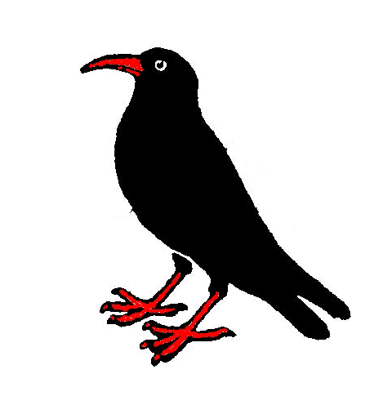

Class 2 – Choughs

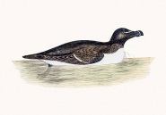

Class 3 – Razorbills

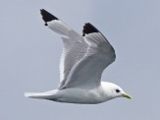

Class 4 – Kittiwakes

**After School Clubs**

Our clubs will resume again in the next couple of weeks and start dates will follow shortly. If your child would like join any of the following clubs please email your permission to [secretary2@landewednack.sch.cornwall.uk](mailto:secretary2@landewednack.sch.cornwall.uk) alternatively see Lyndsay Bray to sign each club list.

**Netball – years 3-6, Tag Rugby – years 3-6, Football – years 1-6, Choir years 3-6.**



**Invitation to the**

**Education Sunday Service**

**At Truro Cathedral**

**Sunday, September 17, 2017, from 2-3pm**

**A service by children and young people. For children and young people on the theme of Community. We would love to see each of Cornwall’s schools represented by children**

**and adults. All are welcome!**



**Sailing – Kittiwakes Class**

Sailing starts again for the children in Kittiwakes class on Tuesday 12th September. The sessions will run up to Tuesday 3rd October. Please see Mr Griffin if you need any further information.

|  |
| --- |
|  |

|  |
| --- |
|  |
|  |

**Future Events and Diary Dates**

**Please note that current dates and times may change. This list is updated each week.**

Friday 22nd September – Jeans for Genes Day 2017

Thursday 19th October - Harvest Festival, The Lizard Methodist Chapel 1.30pm

Friday 20th October – Break up for half term @ 3.15pm

Monday 30th October – Return to school

Friday 1st December – Lizard Lifeboat Station’s Christmas Carolaire 7pm **School Choir to perform**

Wednesday 13th December – Christmas Lunch

Thursday 14th December – Infant Nativity 2pm

Friday 15th December – Infant Nativity 2pm

Tuesday 19th December – Junior Carol Service, St Wynwallow Church 6.30pm

Wednesday 20th December – Christmas Party & Break up for Christmas Holiday @ 1pm

Thursday 4th January 2018 – Return to school

Friday 9th February 2018 – Break up for half term @ 3.15pm

Monday 19th February 2018 – Return to school

Thursday 29th March 2018 – Break up for Easter @1pm

Monday 16th April 2018 – Return to school

Monday 7th May 2018 – School & Little Lizards Closed

Tuesday 8th May 2018 – School & Little Lizards Closed

Friday 25th May 2018 – Break up for half term @ 3.15pm

Tuesday 5th June 2018– Return to school

Wednesday 13th June 2018 – Move Up Day! & Cluster Sports years 3 -6

Friday 20th July 2018 – Break up for the summer holiday @ 1pm

Please also check our school website calendar for further important dates, information and recent events - www.landewednack.cornwall.sch.uk